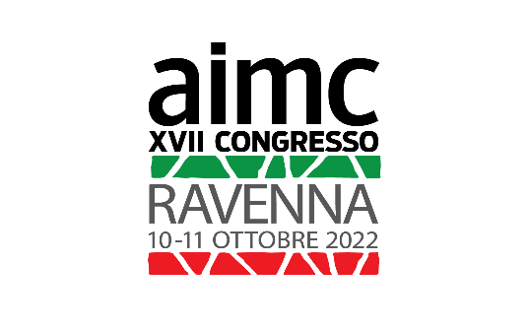

Technical data sheet
to fill in and send by 15/07/2022 at:
info@aimcinternational.org

XVII AIMC CONGRESS-RAVENNA 2022
From 10 to 11 October 2022

Author:

Title of the work:

Materials used:

Dimensions in cm:

Year of execution:

Eventual indication for the setting up of the work:

Short Bio in Italian language (Max 500 characters including spaces)

Short bio in English language (Max 500 characters including spaces)

