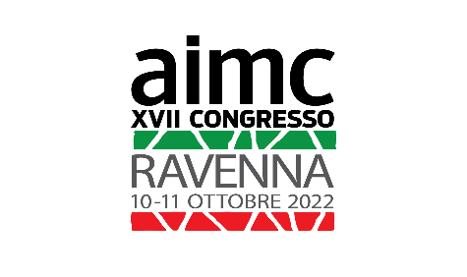
REGISTRATION FORM
to fill in and send back by 15/07/2022 to:
info@aimcinternational.org

XVII AIMC CONGRESS-Ravenna ITALY 2022
From 10 to 11 October 2022
AIMC ASSEMBLY meeting, Members΄ Dinner
9 October 2022

SURNAME:
NAME:
CITY:
COUNTRY:
E-mail:
I request registration for the following events: (tick the relevant boxes)  Participation to the XVII Congress and the exhibition  From Monday 10 to Tuesday 11 October 2022  YES  Participation to the XVII Congress  From Monday 10 to Tuesday 11 October 2022  YES  Name of person(s) accompanying the aimc member:  Participation to the Assembly meeting (only for members)  Sunday 9 October 2022  YES NO  Participation to the members’ dinner  Sunday 9 October 2022  YES NO  Number of persons:  Payment method:  Bank remittance (all charges are at the participant’s expense)  IBAN IT96Z0627013100CC0000033781  Paypal: info@aimcinternational.org  Please add 3 euros for remittance expenses | euro 120  euro 100
I ask to participate as a speaker:
15 minutes presentations.
Title of the presentation:

YES

Intervention language:

ITALIAN | ENGLISH

The presentation should be written in ITALIAN AND IN ENGLISH

I ask to participate only to the exhibition  YES | euro 50

