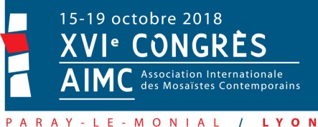
Registration required before June15, 2018 - beyond this date, the costs may be increased
NAME:
Surname:
Address :
City: Postal Code/Zip:
Country:
E-mail:
I sign up for the AIMC Congress FRANCE 2018  Paray-Le-Monial (included buffet, music show and gala dinner)  from Monday October 15th to Wednesday October 17th 2018  ☐ yes ☐ no  I sign up for the post-congress Lyon, Vienne, Saint-Romain-en-Gal  Thursday 18th and Friday october 19th 2018 (included transport by bus buffet of Thursday and dinner at Georges)  ☐ yes ☐ no  I sign up for the visit to Elaine M Goodwin's Gallery in Couches  (included transport by bus and vernissage buffet)  ☐ yes ☐ no  Total cost:  Payment:  - by check payable to the order: AIMC FRANCE 2018 (France only)  - by bank transfer (all charges are at the participant's expense, often free in Europe)  IBAN : FR7610278073750002040840153 BIC : CMCIFR2A  Account holder : AIMC-FRANCE2018  - by Paypal (free for you) : aimcfrance2018@orange.fr | 100 €  70 €  15 €  … €

I would like to make an oral presentation : ☐yes ☐ no

The practical arrangements will be sent to you after registration.
language of my oral presentation : ☐french ☐english
I will send my text in : ☐french ☐english

I will send a personal mosaic to be exhibited during the congress: ☐yes ☐ no
The practical arrangements will be sent to you after registration.
A catalog will be published.

Registration form to be sent back
- by e-mail: aimcfrance2018@orange.fr
- by mail: AIMC FRANCE, 27 montée de l'école 73710 PRALOGNAN FRANCE

